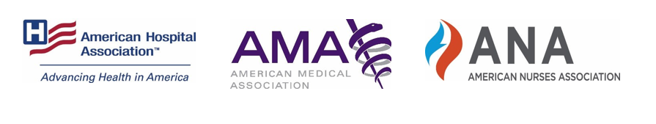

AHA, AMA AND ANA RELEASE PUBLIC SERVICE ANNOUNCEMENT AS PART OF CAMPAIGN URGING THE PUBLIC TO WEAR A MASK TO HELP STOP THE SPREAD OF COVID-19
WASHINGTON (July 31, 2020) – Together, the American Hospital Association (AHA), the American Medical Association (AMA), and American Nurses Association (ANA) released a public service announcement (PSA) today urging the American public to take three simple steps to help stop the spread of COVID-19: wear a mask, practice physical distancing and wash hands frequently. The PSA is the first element of a comprehensive campaign to increase public acceptance of these essential actions and builds on the groups’ open letter to the public released last month.
Physicians, nurses and hospital and health systems leaders have been joined by researchers and public health experts in this important call to action. The science and evidence is clear, following these guidelines is essential to helping to stop the spread of the virus.

Following months of practicing physical distancing and staying home, both COVID-19 infections and deaths began to decline. As states began reopening, people started to abandon the essential steps needed to stop the spread. This led to a significant increase of new cases, worsening the shortage of personal protective equipment (PPE), tests and testing supplies and further stretching hospitals’ intensive care unit (ICU) capacity in certain states. It also exacerbated the mental and physical toll on health care teams and clinicians providing patient care. In response, the AHA, AMA and ANA have launched the #WearAMask campaign as a way to continue urging the American public to wear a face mask, maintain physical distancing and wash hands. By taking these three simple steps, everyone can contribute to stopping the spread of the virus and keeping themselves, their families and their communities safe.
“For months hospitals and health systems and caregivers have heroically battled COVID-19. Following the science, evidence and the advice of our clinical partners when it comes to wearing masks, practicing good hand hygiene and social distancing has proven effective in stopping the spread and now is not the time to go backwards, ” said AHA President and CEO Rick Pollack. “Everyone has a critical role to play and working together we can ease the surge of patients that need to be cared for and to ensure our brave front-line caregivers can win the fight against this virus.”

“COVID-19 respects no geographic, demographic or ideological boundaries, and unfortunately it shows no signs of going away any time soon,” said AMA President Susan R. Bailey, M.D. “But there are simple steps we can all take to protect ourselves, our loved ones, and our communities. The AMA is proud to stand with nurses and health system leaders to urge everyone to #WearAMask and #MaskUp. Make masks part of your daily wardrobe and regular routine. By wearing a cloth mask, practicing physical distancing, and regularly washing our hands, we can all prevent the spread of COVID-19.”
“When we wear a mask and practice physical distancing and diligent hand-washing," explained ANA President Ernest J. Grant, PhD, RN, FAAN, "we are protecting ourselves, our family, our friends, health care workers, and others in our community that we may come into contact with. These steps are critical and effective. If we all do our part, and trust the evidence and science, we can slow the spread of COVID-19 and help our nation recover.
###

About the American Hospital Association
The American Hospital Association (AHA) is a not-for-profit association of health care provider organizations and individuals that are committed to the health improvement of their communities. The AHA advocates on behalf of our nearly 5,000 member hospitals, health systems and other health care organizations, our clinician partners – including more than 270,000 affiliated physicians, 2 million nurses and other caregivers – and the 43,000 health care leaders who belong to our professional membership groups. Founded in 1898, the AHA provides insight and education for health care leaders and is a source of information on health care issues and trends. For more information, visit the AHA website at www.aha.org.
About the American Medical Association
The American Medical Association is the physicians’ powerful ally in patient care. As the only medical association that convenes 190+ state and specialty medical societies and other critical stakeholders, the AMA represents physicians with a unified voice to all key players in health care. The AMA leverages its strength by removing the obstacles that interfere with patient care, leading the charge to prevent chronic disease and confront public health crises and, driving the future of medicine to tackle the biggest challenges in health care.
About the American Nurses Association
The American Nurses Association (ANA) is the premier organization representing the interests of the nation's 4 million registered nurses. ANA advances the nursing profession by fostering high standards of nursing practice, promoting a safe and ethical work environment, bolstering the health and wellness of nurses, and advocating on health care issues that affect nurses and the public. ANA is at the forefront of improving the quality of health care for all. For more information, visit www.nursingworld.org. For high-resolution images of the ANA logo or photos of ANA leadership, please click here.

